**INTRODUCTION**

Amazon S3 is a Cloud-based Storage Service that helps you store and receive files over the internet. It is commonly used for hosting websites, sharing files, storing backups, big data analytics etc. It is secure, reliable, durable and always available.

**PREREQUISITES**

* AWS Account
* Static website file
* Bucket policy for website access

**STEP 1**: **CREATE AN AWS ACCOUNT**

Set up your account by signing into AWS Console to create an account or sign in to an already AWS Account. On the AWS Console, ensure you have the necessary permissions for S3. Navigate to S3 service in the AWS Management Console to create a Bucket.  
(A bucket is a container for storing objects in S3)

**STEP 2**: **CREATE A NEW S3 BUCKET**

Now we need to go to the S3 Console and Click "create Bucket".  
Select General purpose and enter a unique bucket name for the bucket as well as selecting a desired region.

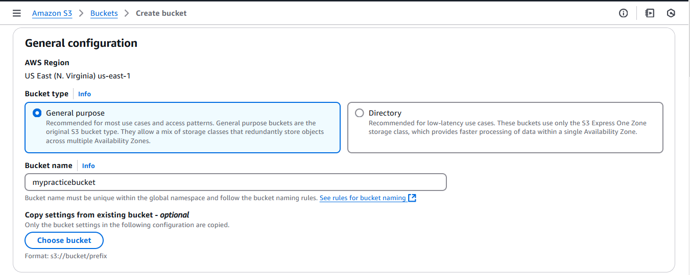

Disable "block all public access" and tick the "I acknowledge that the current settings might result in this bucket and object becoming public" to confirm you want to make the bucket public.

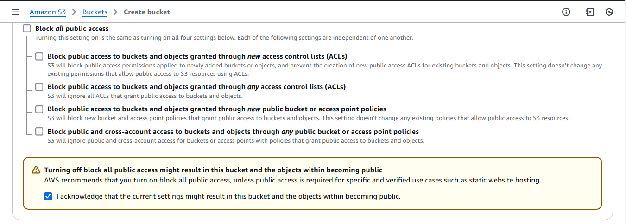

Enable versioning for tracking file changes (optional). Leave every other settings on default and click “create bucket” to finish.

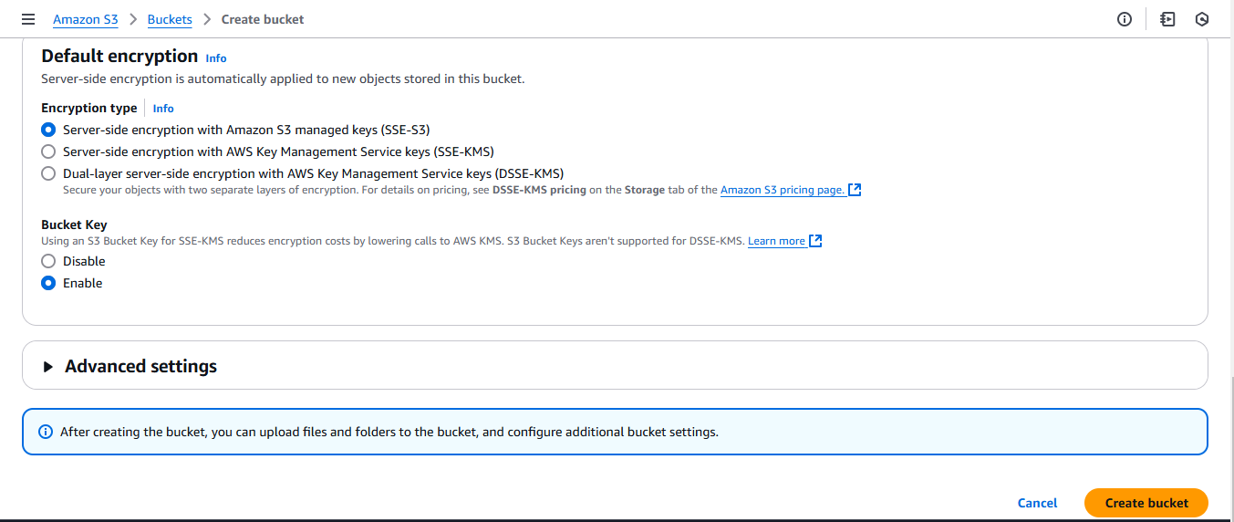

**STEP 3: ENABLE STATIC WEBSITE HOSTING**

A static website is a website that consists of fixed content which displays same information to everyone accessing the website

Open the S3 bucket created and navigate to properties tab

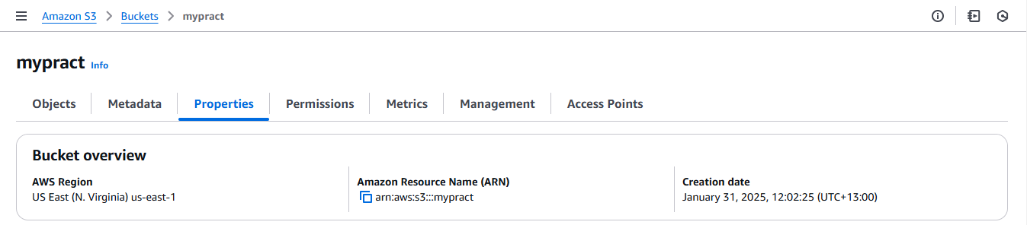

Scroll down to static website hosting and choose “Enable” and select “Host static website”. In the Index document, type index.html and click save changes.

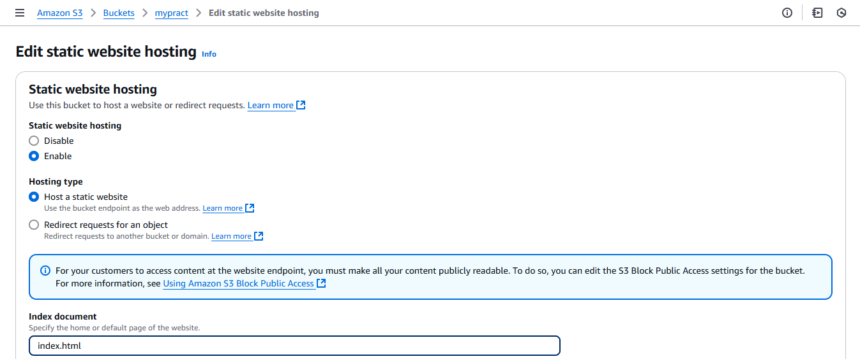

**STEP 4: UPLOAD AN OBJECT (a website file)**

An Object is a file stored in S3. Each object has a Key (file name), Value (data) and a Metadata.

Click on the newly created bucket to Open the bucket and Click “upload” to upload a file or folder.

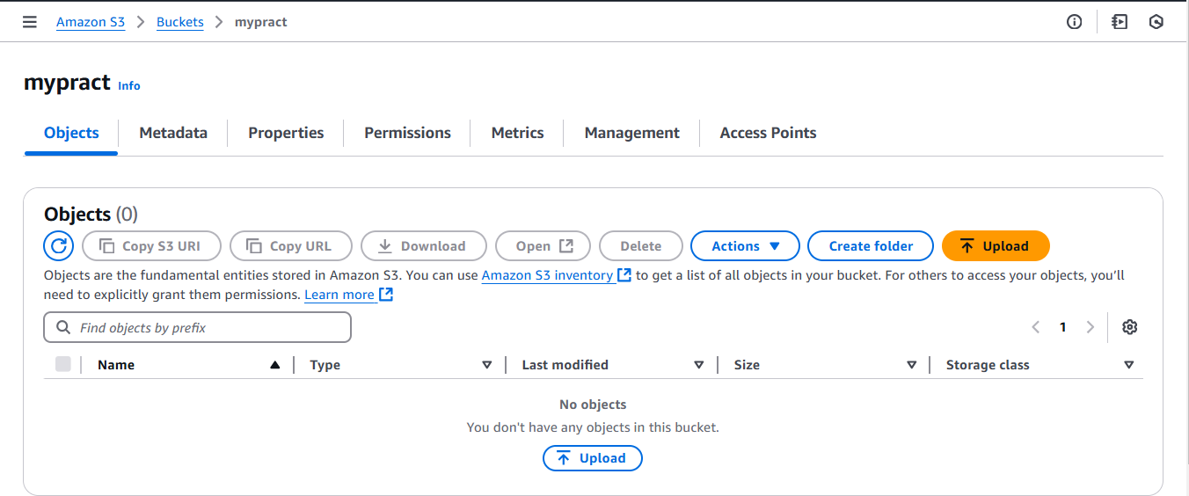

Click Add files or folders to add your index.html file or any other file or folder.

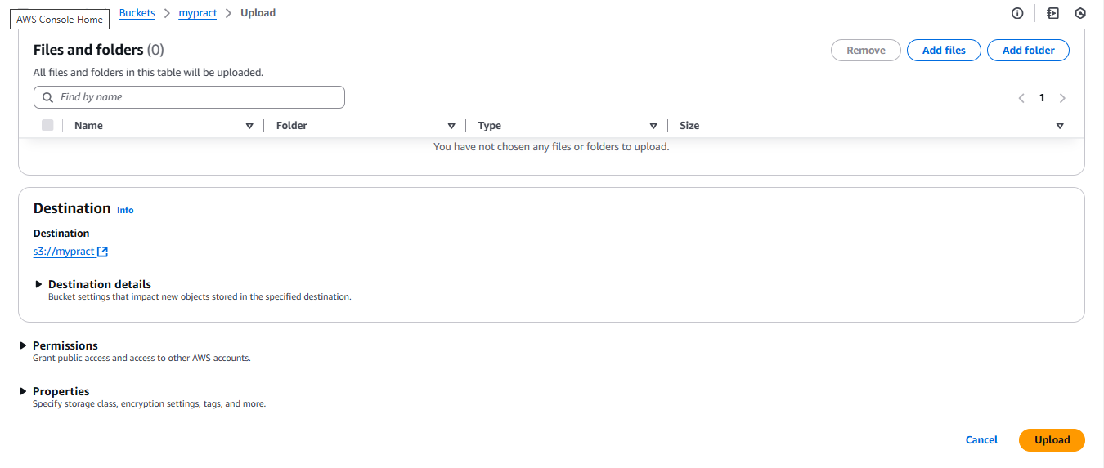

Click upload and your file will be successfully uploaded. Ensure the files have a public access by selecting the object and clicking on actions to make public using ACL, confirm and make changes.

**STEP 5**: **SET BUCKET POLICIES TO MAKE YOUR FILES PUBLIC**  
Policies are rules that define permissions for users or groups in AWS.  
Navigate to the bucket created.

Go to the permission tab and scroll down to bucket policy tab

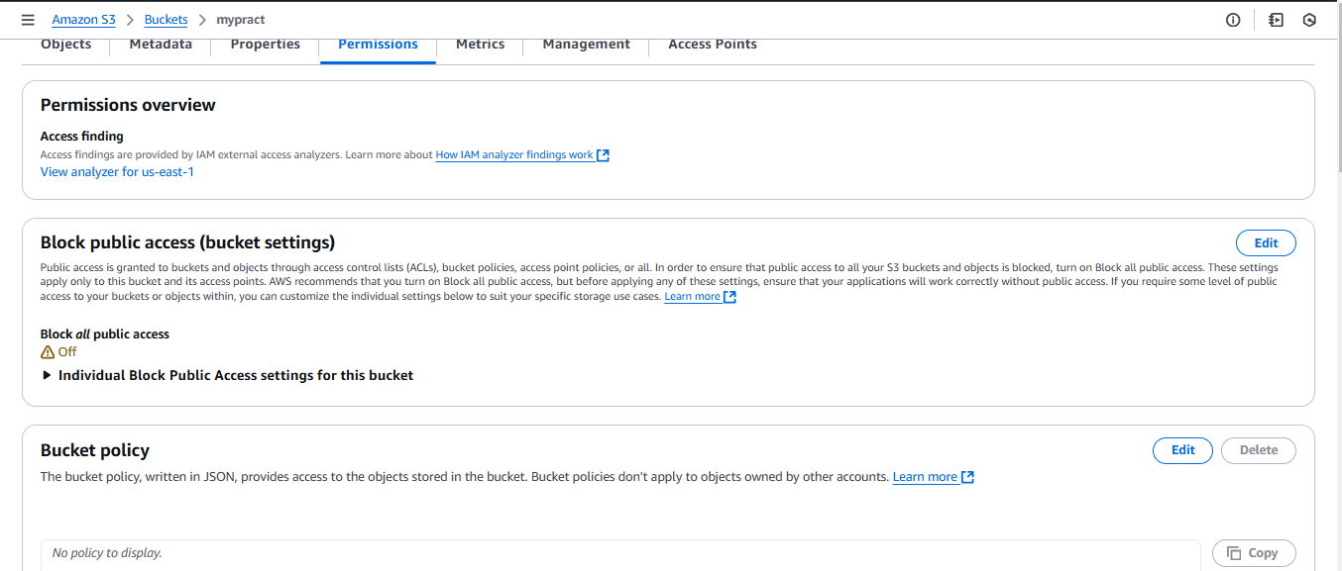

Click on Edit to add a JSON policy that will make your files public replacing “your bucket” name with the name of your S3 bucket which was created. Click save changes to save the policy updated.

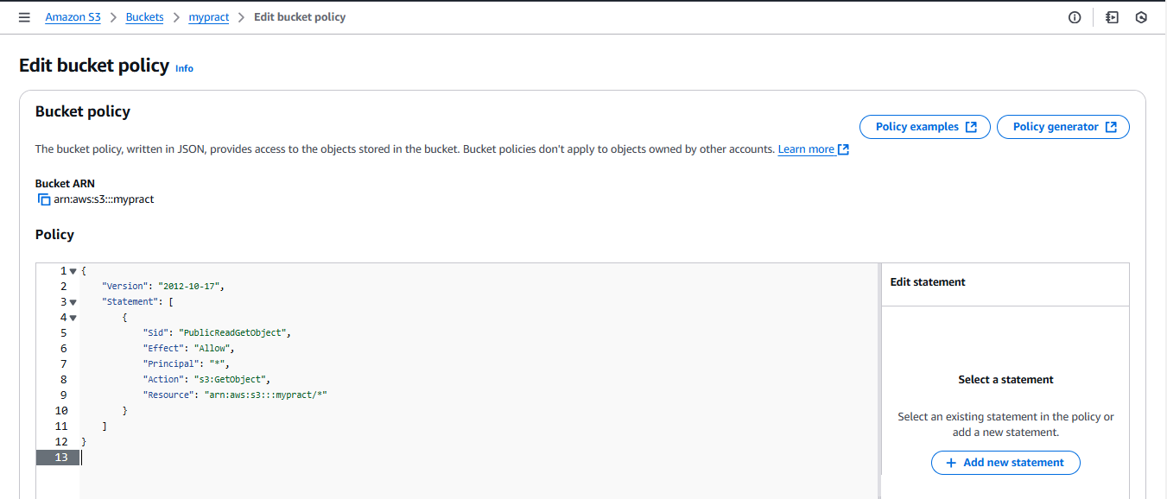

**STEP 6: ACCESS THE WEBSITE**  
 Navigate to the "Properties" tab and under the "static website hosting", copy the bucket website endpoint.

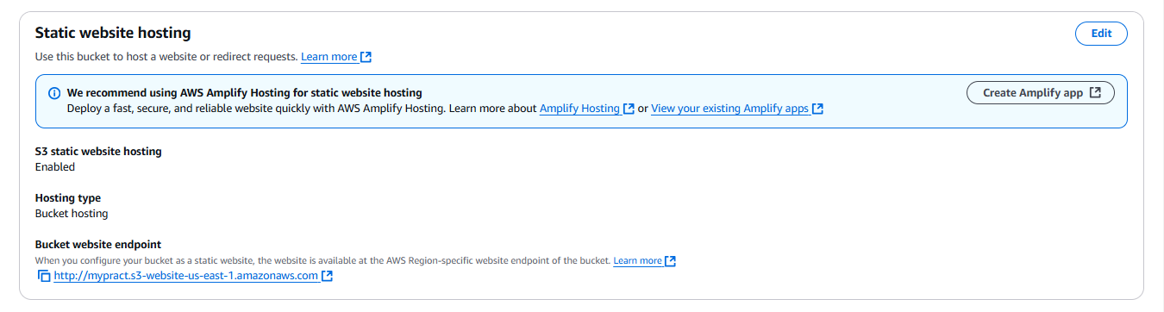  
 Paste the URL into a new tab in your browser to view your static website.

[](https://media2.dev.to/dynamic/image/width=800,height=,fit=scale-down,gravity=auto,format=auto/https:/dev-to-uploads.s3.amazonaws.com/uploads/articles/43nf7lcd6kalif91fmo3.png)

STEP 7: EMPTY THE S3 BUCKET

Go to the console and open S3. Click on the bucket name and select “Empty” to remove all files. Confirm by typing “Permanently delete” and clicking “Empty”.

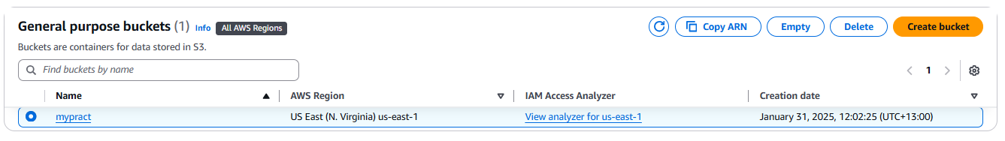

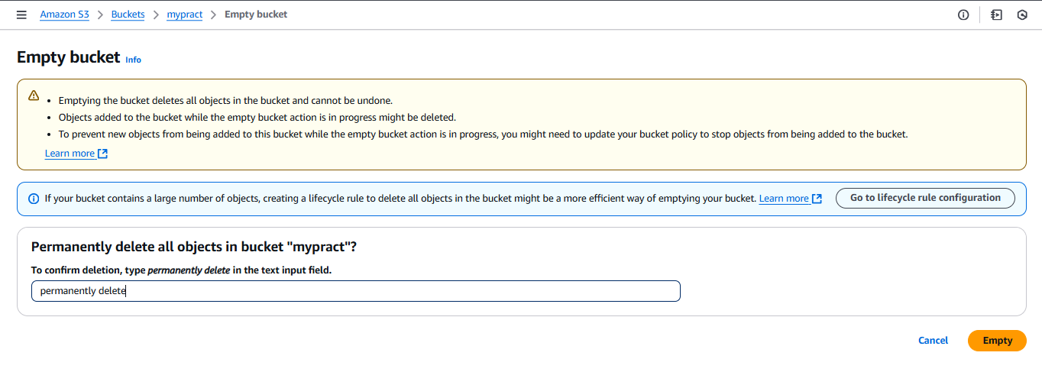

In the S3, go to the Bucket lists and select the bucket you want to delete. Click delete bucket and confirm by typing the Bucket name and clicking “Delete”.

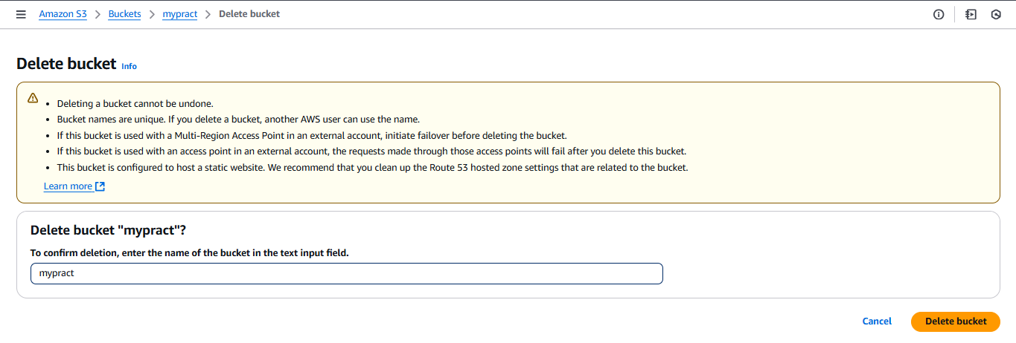

**CONCLUSION**

Amazon S3 provides a simple and reliable way to host a static website with minimal cost and effort. It allows for easy deployment, availability and scalability. With a few configurations, you can quickly deploy a website to a global audience.

This article serves as an overview, providing steps on how to host a static website on S3 in AWS.